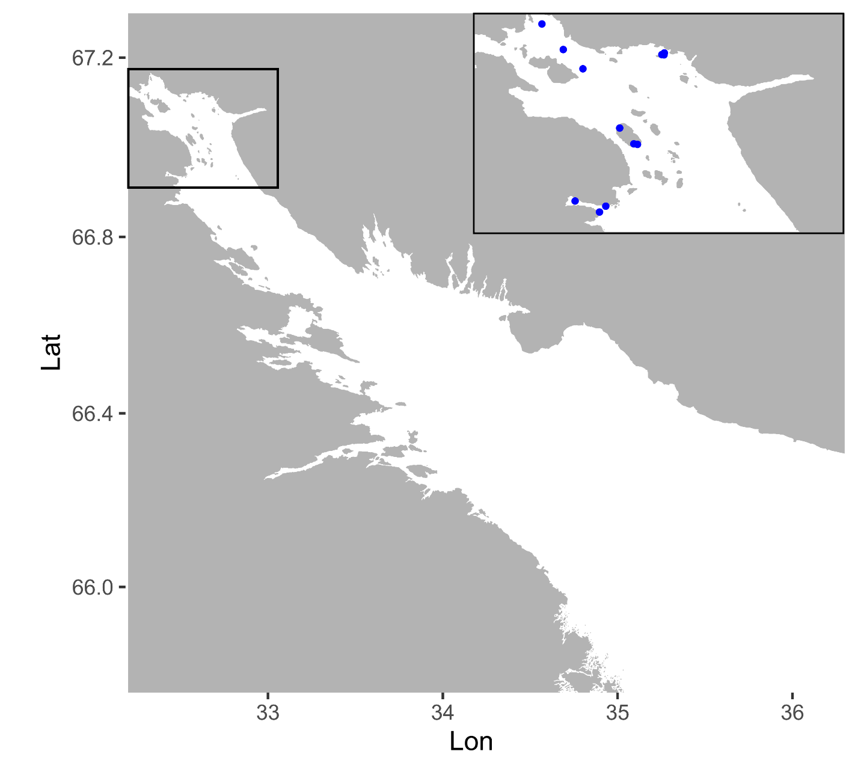

Figure S1. Material collection sites for the Kandalaksha littoral testing dataset in the Kandalaksha Bay of the White Sea.